

Web Programming For Mobile Devices Project

GLOBAL PERSPECTIVE SPORT

Group 5

Names : Rayhan Rizky Aqshal

Musa Habiburrohman

Class : 3SC6

CEP CCIT

FAKULTAS TEKNIK UNIVERSITAS INDONESIA

2021



**Developed By**

1. **Rayhan Rizky Aqshal**
2. **Musa Habiburrohman**

**PROJECT ON**

*Global Perspective Web*

Batch Code : 3SC6

Start Date : 15/10/2021

End Date : 22/10/2021

Name of Faculty : Mr. Fachran Nazarullah, S.Kom

Name of Developer :

1. Rayhan Rizky Aqshal
2. Musa Habiburrohman

Date of Submission : 24/10/2021

**Global Perspective Sport**



**CERTIFICATE**

This is to certify that this report titled “Global Perspective Sport Web” embodies the original work done by Rayhan Rizky Aqshal and Musa Habiburrohman. Project in partial fulfillment of their course requirement at NIIT.

Coordinator :

Mr. Fachran Nazarullah, S.Kom

Praise and gratitude the author goes to the presence of God Almighty for His blessings and grace, we were able to complete this project task both in the form of presentations and papers on time.

The author also thanks Mr. Fachran Nazarullah and other lecturers for all their guidance to complete it. Thank you to fellow students who have supported, and also thank you to fellow education staff at CCIT-FT UI. Project Paper entitled “Global Perspective Sport” which the author submitted as a requirement for Project assignment in 2021.

Finally, the author hopes that this paper can be useful for all and also add a better insight into the operating system. The author realizes that it is still not perfect. Therefore, the author expects all suggestions and criticisms from readers that are constructive for the perfection of this paper. Hopefully this paper can provide many benefits for readers.

**ACKNOWLEDGEMENT**

**SYSTEM ANALYSIS**

**System Summary :**

In this project we use the bootstrap framework in the css section to design the navigation bar. then use jQuery to add some features such as content tabs, star rating, smooth scrolling, and loading json data.

**INTRODUCTION**

"Global Perspective Sport" (hereinafter referred to as GPS) is a company engaged in sports, ranging from sports equipment to providing sports facilities that can be rented by the public.

On the web this time we will expand our services by providing the hottest news about the world of sports. also made online reservation.

**ACTIVITY LIST**

|  |  |
| --- | --- |
| * 18/10/2021 | Start Project |
| * 18/10/2021 | Decides Project Theme |
| * 20/10/2021 | Compile navigation bar |
| * 20-22/10/2021 | Compile reservation page |
| * 23-25/10/2021 | Compile news page |
| * 26/10/2021 | Compile store pages |
| * 27/10/2021 | Compile about us page |
| * 28/10/2021 | Finish Compile home page |
| * 1-3/11/2021 | Make word and PPT |
| * 5/11/2021 | Presentation |

**DESIGN OF APPS**

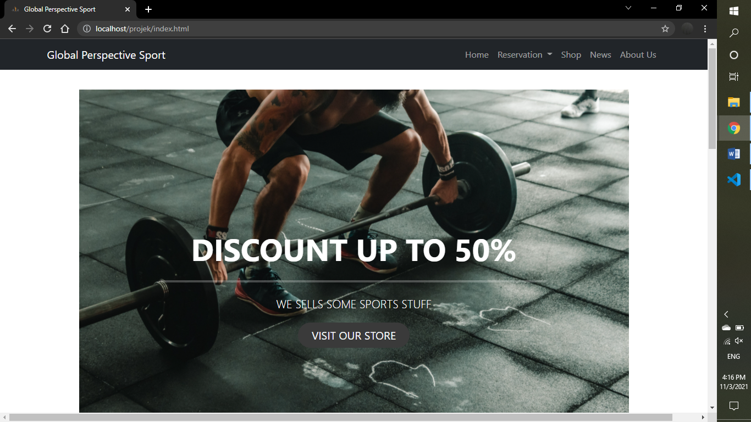

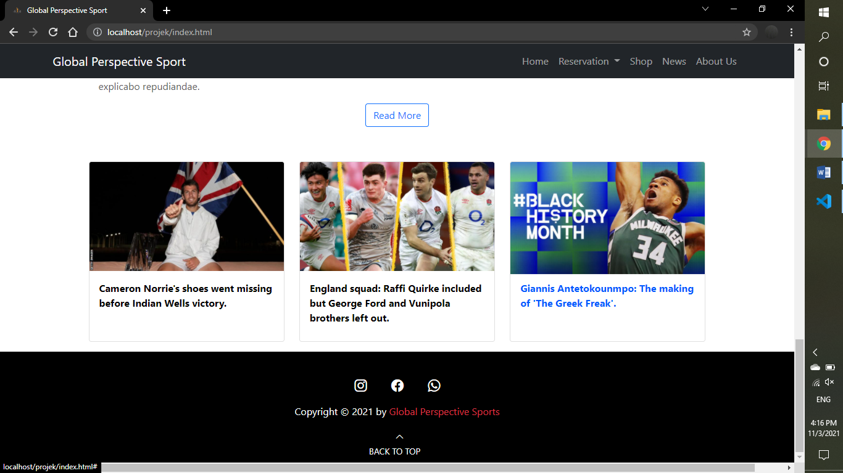

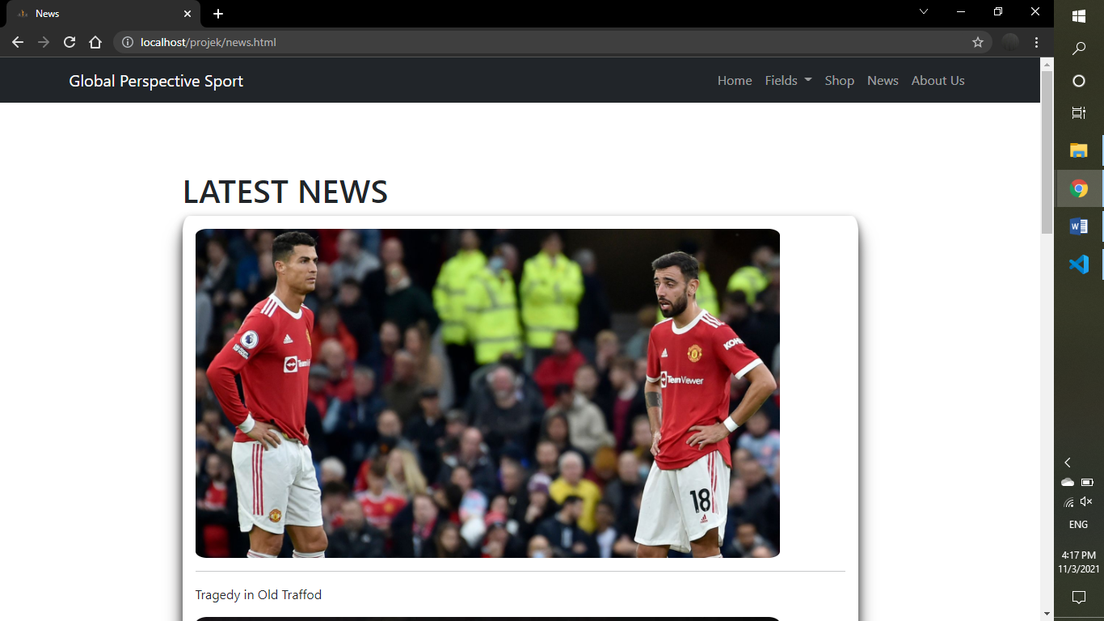

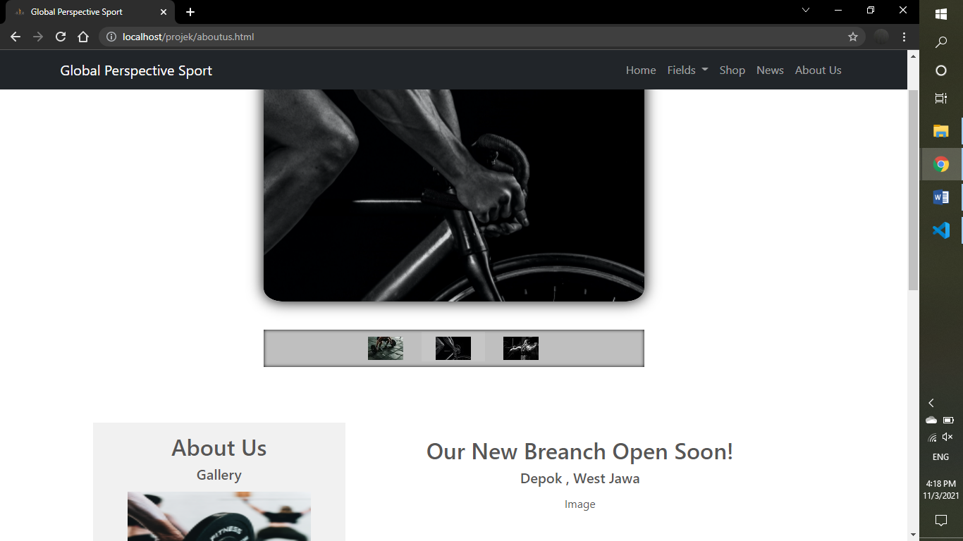

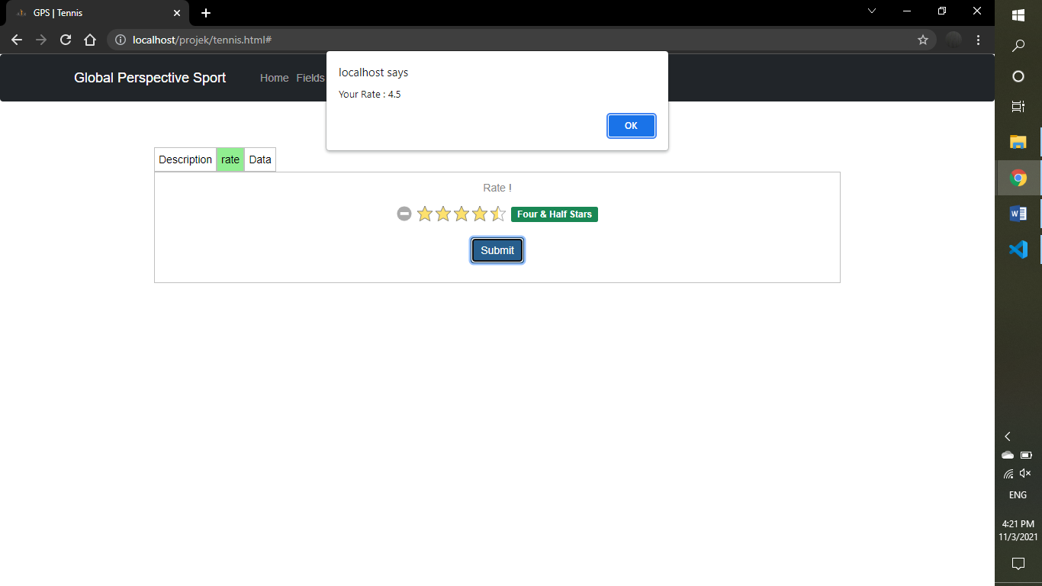

**IMPLEMENTATION**

Code for index content

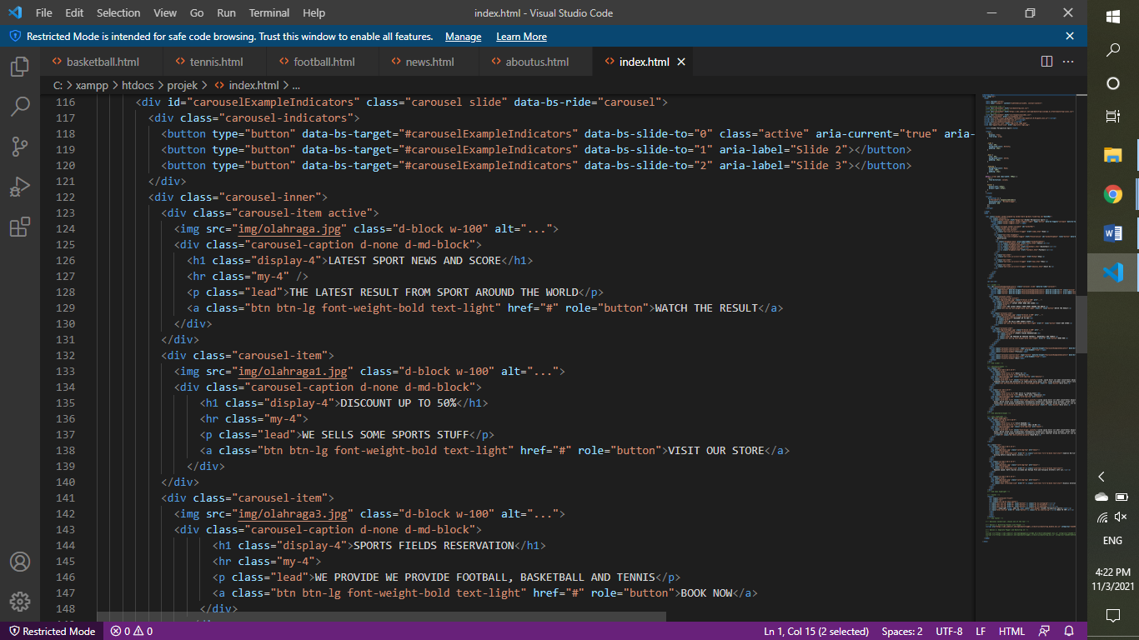

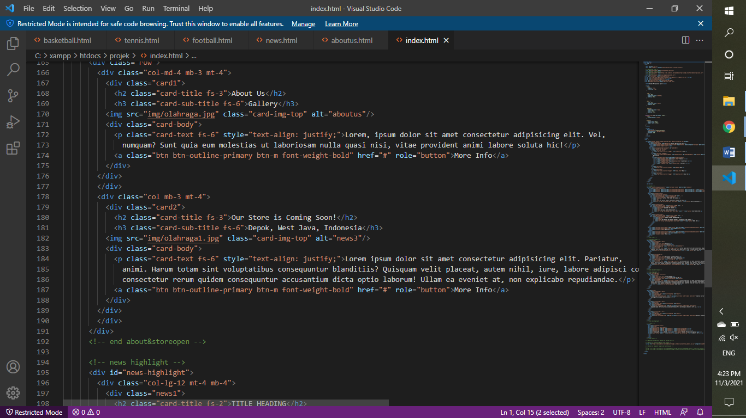

Code for news index and footer

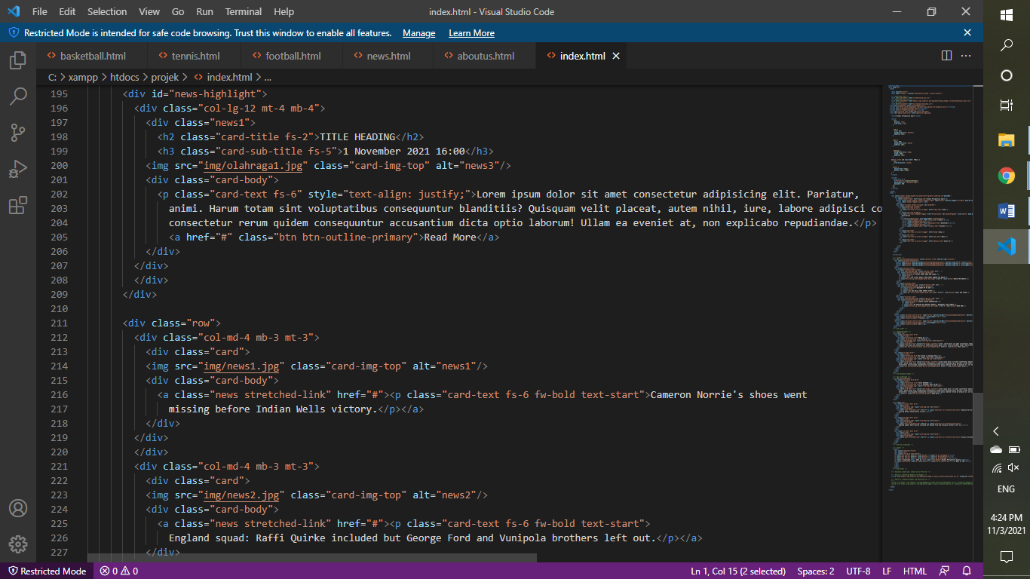

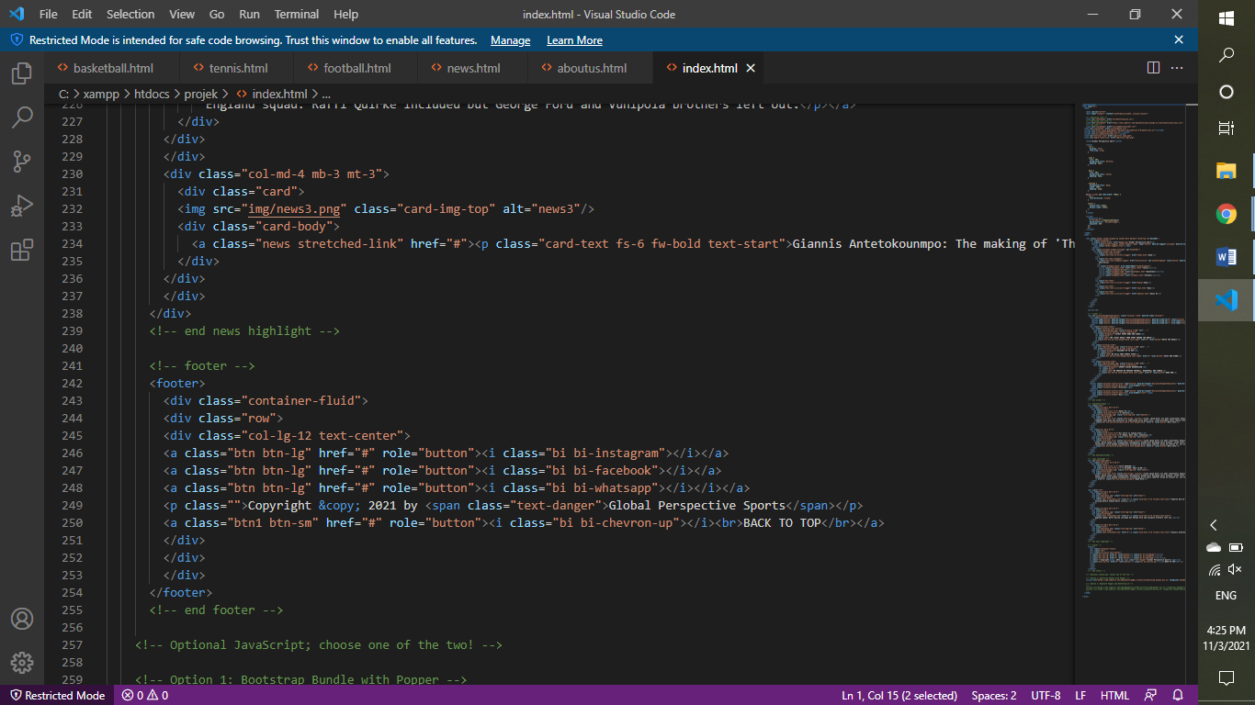

Code for news page and json item push

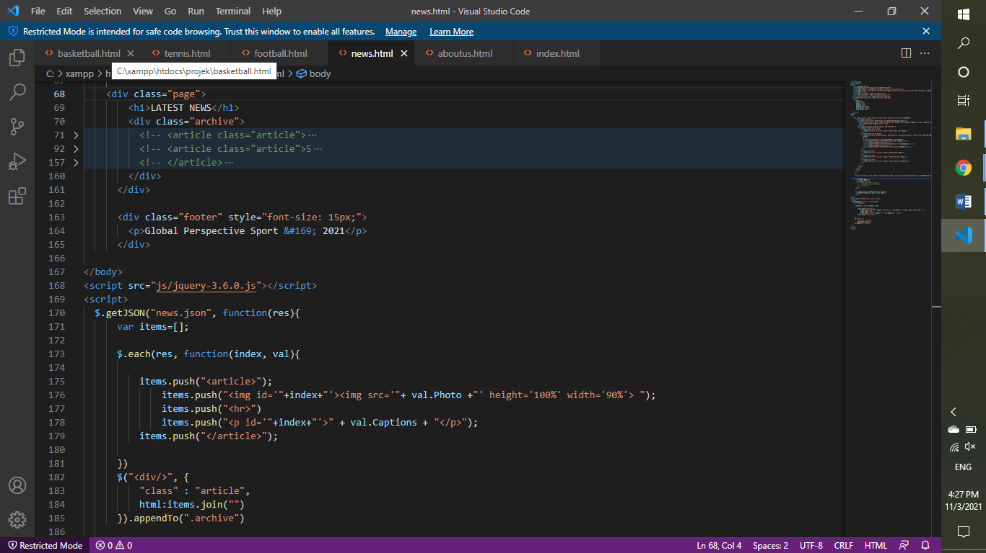

more can be found at https://github.com/muusah/GPS1

**PREVIEW OF APPS**

Application Preview using Screenshot:

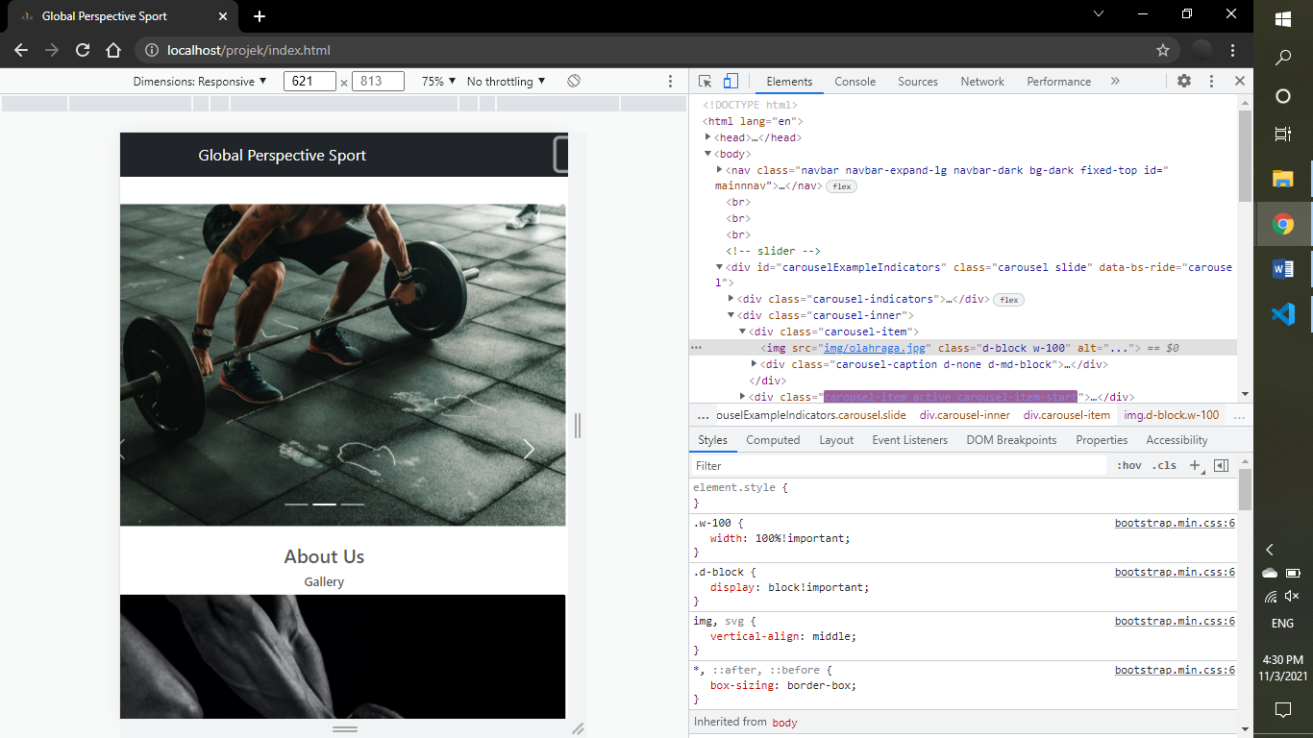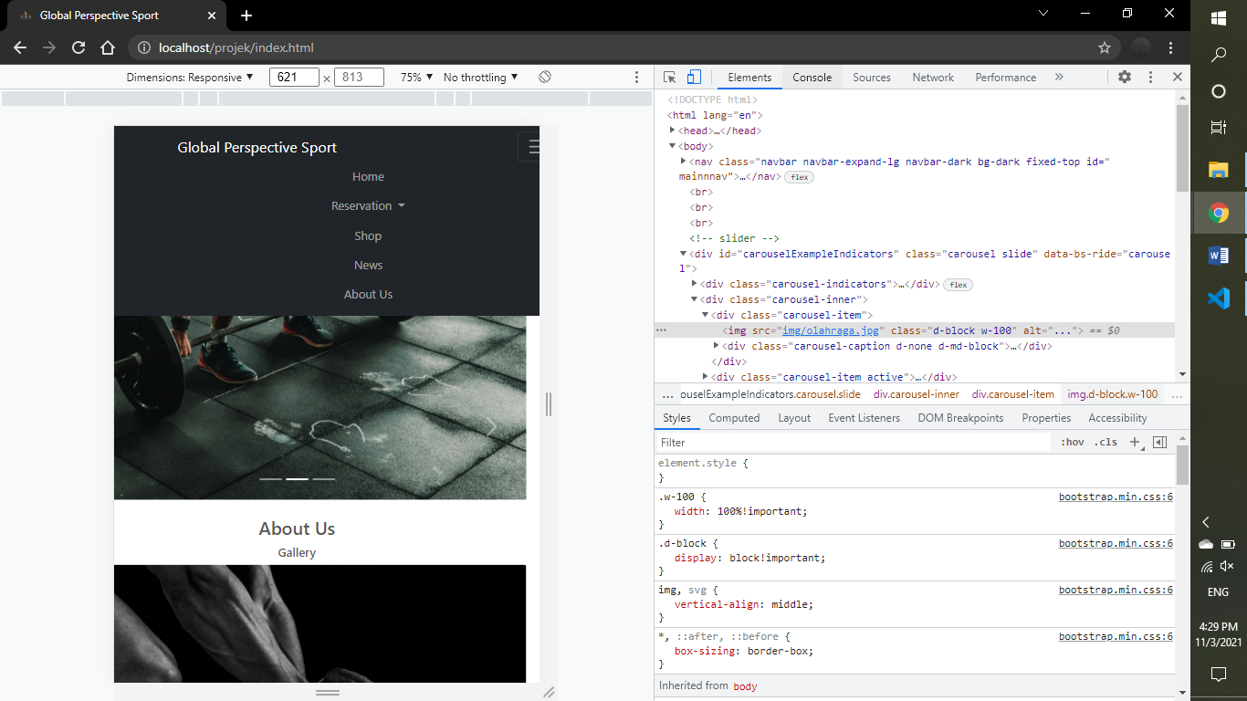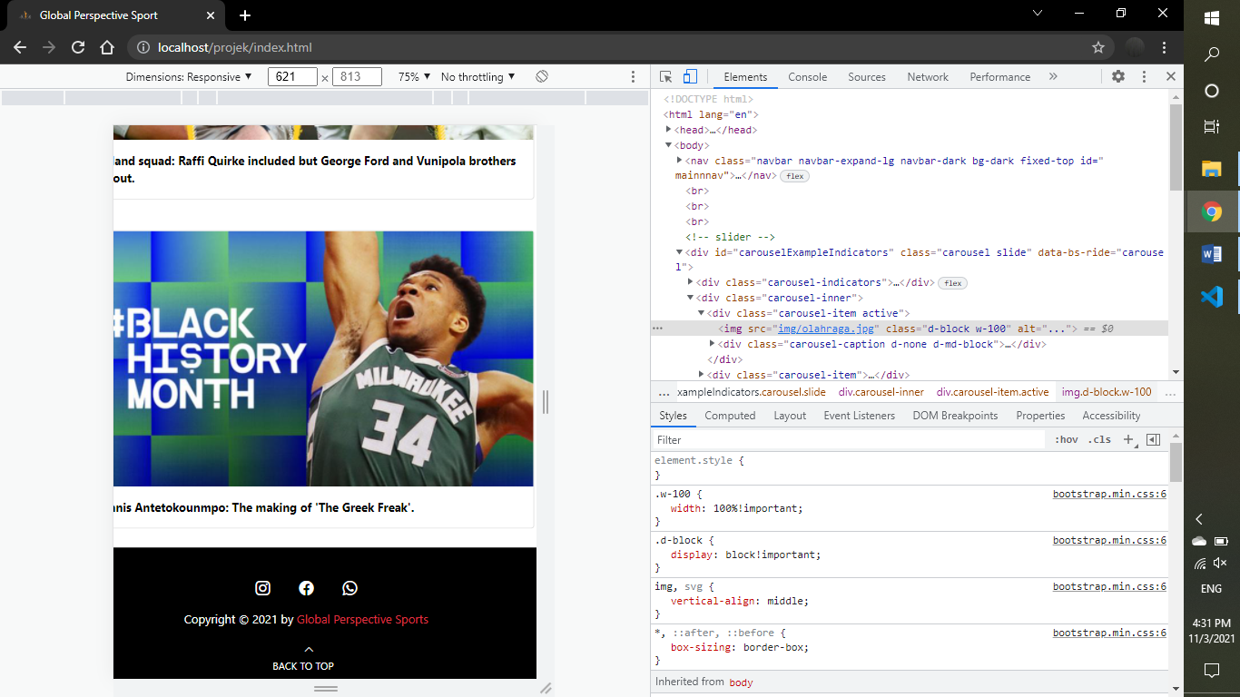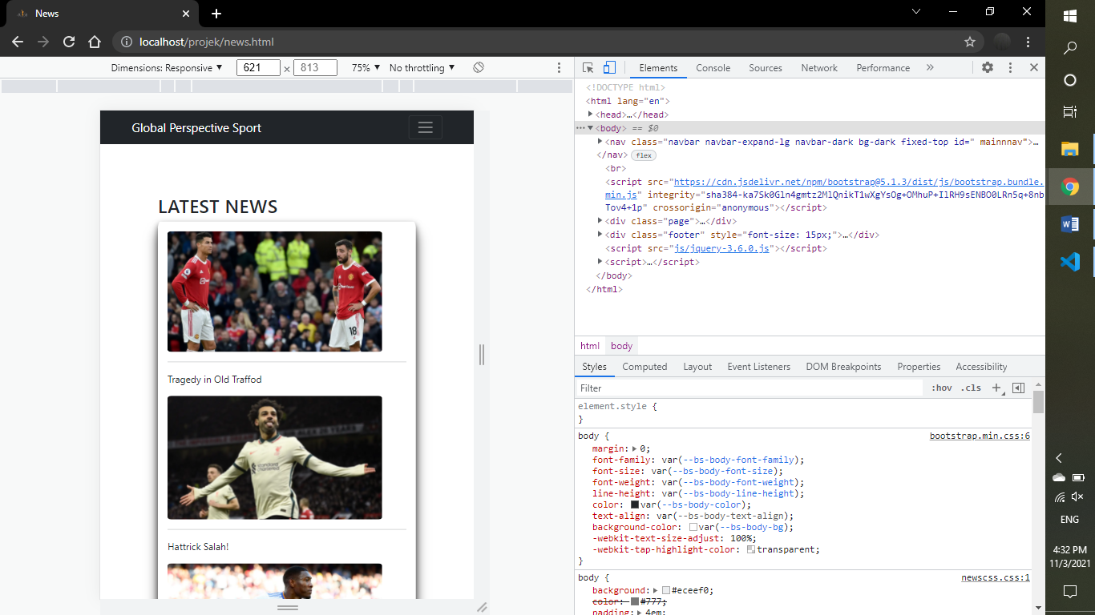

|  |  |
| --- | --- |
| **Hardware** | 1 gigahertz (GHz) or faster processor or SoC.  RAM: 1 gigabyte (GB) for 32-bit or 2 GB for 64-bit.  Hard disk space: 4 GB |
| **Operating System** | Windows 10 Home |
| **Software** | Sublime text(HTML,CSS,JavaSript)  Google Chrome/Microsoft Edge/Any Browser with internet connection |

|  |  |  |
| --- | --- | --- |
| **PROJECT FILE DETAILS** | | |
| **S.No** | **File Name** | **Remarks** |
| 1 | Project – GPS. rar | HTML Files compressed |
| 2 | PROJECT Global Perspective Sports. word | Our results journal |
| 3 | PROJECT Global Perspective Sports. pptx | PowerPoint Slides |
| 4 | Index.html | Landing page |
| 5 | Jquery-3.6.0.js | jQuery library |
| 6 | Infotainment.html | Contain information and entertainment page |
| 7 | Tabstyle.css | CSS for tab content |
| 8 | Tabjs.js | jQuery js for tab content |
| 9 | tennis.html , basketball.html , football.html | Information about sport facilities and its reservation page |
| 10 | Star-rating.css | CSS library for rating star feature |
| 11 | Bootstrap.min.css | CSS library of bootstrap |

**CONFIGURATION**